TDI SQL CAPSTONE PROJECT; SQL SCRIPT
NAME: FELICITAS EZECHIKELUBA
TRACK: DATA ANALYTICS
COHORT: SAPPHIRE
TOOL: SQL
MAVEN TOYS RETAIL STORES PERFORMANCE ANALYSIS
INTRO
–-Before diving into analysis, the datasets were first cleaned and explored to ensure accuracy and consistency.

DATA EXPLORATION AND CLEANING
This process was carried out table by table to ensure completeness, consistency, and accuracy across the dataset.

- STEP ONE EXPLORATION AND DATA CLEANING
Data Exploration and cleaning steps included:
- Checking for missing values (NULLs)
- Duplicate Records(Rows)
- Inconsistent Data Formats for string values
- Outliers and Invalid Values
- Leading/Trailing Spaces

- Products Data
SELECT *
FROM MTD_products
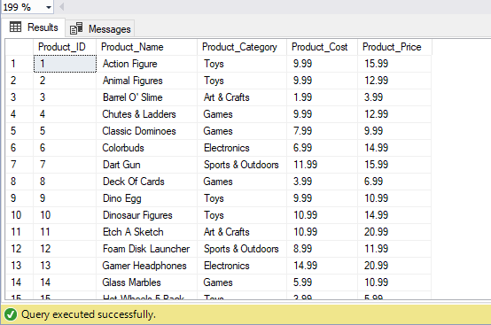
--#Checking for Null values in the Products data

SELECT COUNT(*)
FROM MTD_products
WHERE
[Product_ID] IS NULL OR
[Product_Name] IS NULL OR
[Product_Category] IS NULL OR
[Product_Cost] IS NULL OR
[Product_Price] IS NULL

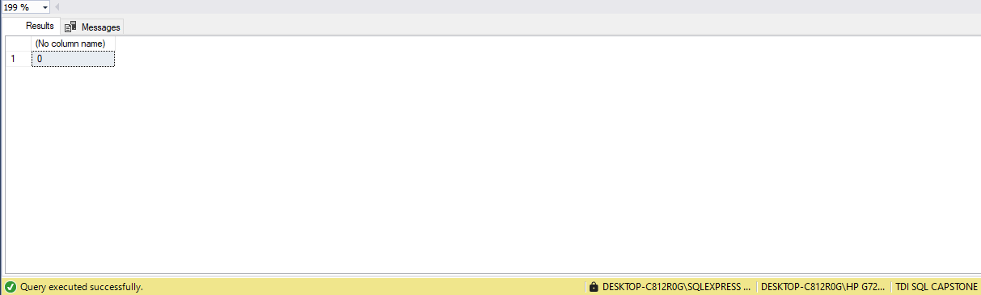
--# Result shows no Null Value

--#Checking for Duplicate Columns and rows in the Products data

--All Records
SELECT *, COUNT(*) AS DuplicateCount
FROM MTD_products
GROUP BY[Product_ID],[Product_Name],[Product_Category],[Product_Cost],[Product_Price] --list of all columns in the table
HAVING COUNT(*) > 1;

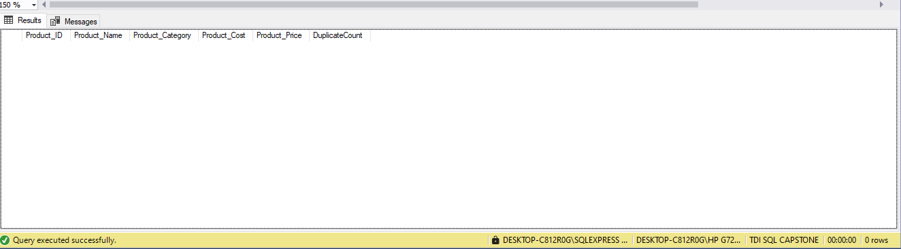

--Product_ID Column
SELECT [Product_ID],COUNT(*)
FROM MTD_products
GROUP BY [Product_ID]
HAVING COUNT(*) > 1;

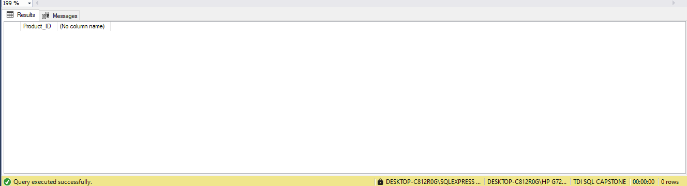
--# Result shows no Null Value

--Product_Name Column
SELECT Product_Name],COUNT(*)
FROM MTD_products
GROUP BY Product_Name
HAVING COUNT(*) > 1;

- Stores Data
SELECT *
FROM MTD_stores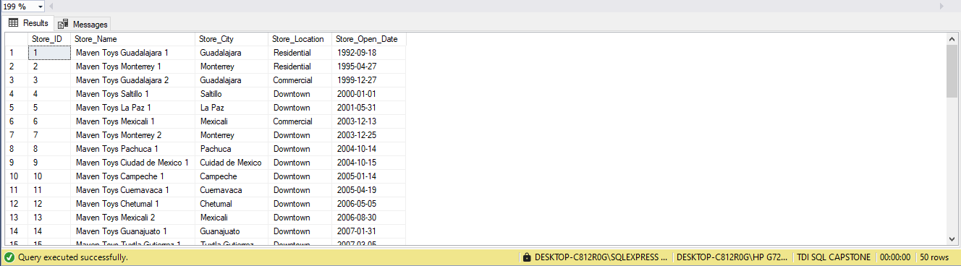

--#Checking for Null values in the Stores Data
SELECT COUNT(*)
FROM MTD_stores
WHERE
[Store_ID] IS NULL OR
[Store_Name] IS NULL OR
[Store_City] IS NULL OR
[Store_Location] IS NULL OR
[Store_Open_Date] IS NULL
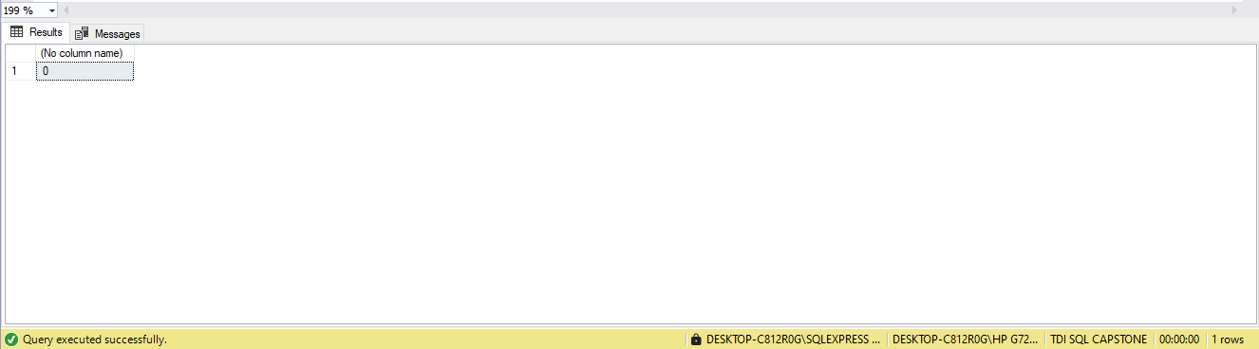
--# Result shows no Null Value

--#Checking for Duplicate Columns and rows in the Stores data

--All Records
SELECT *, COUNT(*) AS DuplicateCount
FROM MTD_stores
GROUP BY[Store_ID],[Store_Name],[Store_City],[Store_Location],[Store_Open_Date] --list of all columns in the table
HAVING COUNT(*) > 1;
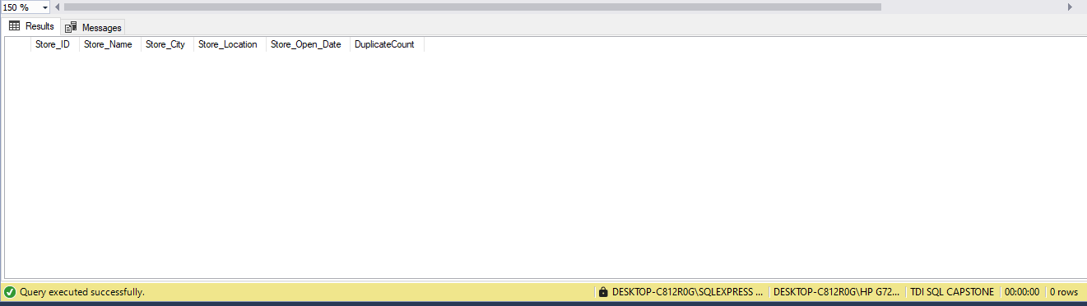

- Sales Data

SELECT *
FROM MTD_Sales

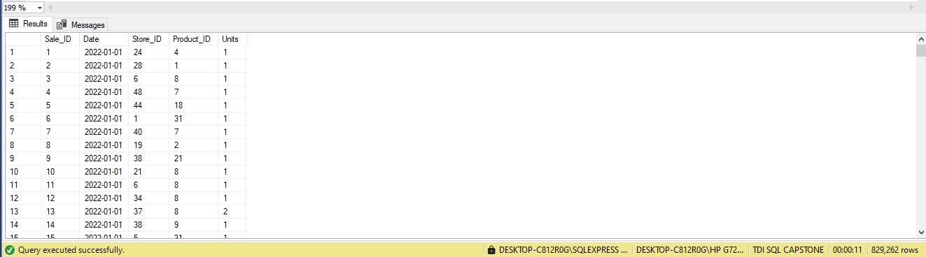

--#Checking for Null values in the Sales Data

SELECT COUNT(*)
FROM MTD_sales
WHERE
[Sale_ID] IS NULL OR
[Date] IS NULL OR
[Store_ID] IS NULL OR
[Product_ID] IS NULL OR
[Units] IS NULL
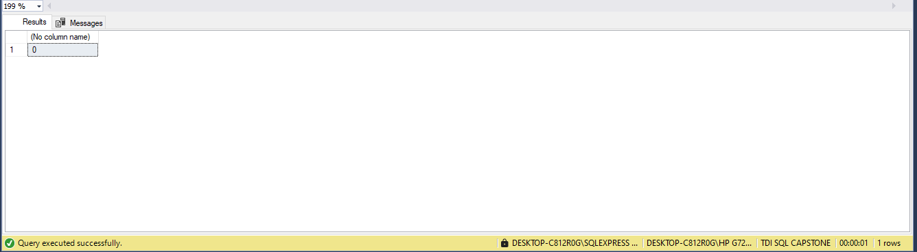
--# Result shows no Null Value

--#Checking for Duplicate Columns and rows in the Sales data

--All Records
SELECT *, COUNT(*) AS DuplicateCount
FROM MTD_sales
GROUP BY[Sale_ID],[Date],[Store_ID],[Product_ID],[Units] --list of all columns in the table
HAVING COUNT(*) > 1;

--#Checking for Outliers and Invalid Values
SELECT * FROM MTD_Sales WHERE Units < 0;

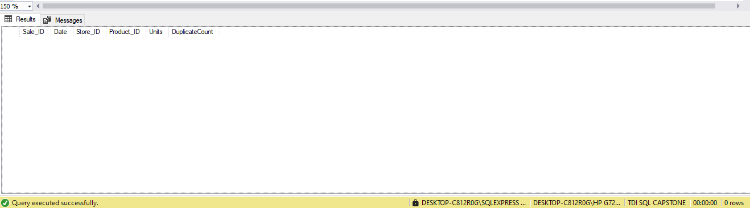
--# Result shows no Null Value for both issues

- Inventory Data

SELECT *
FROM MTD_Inventory

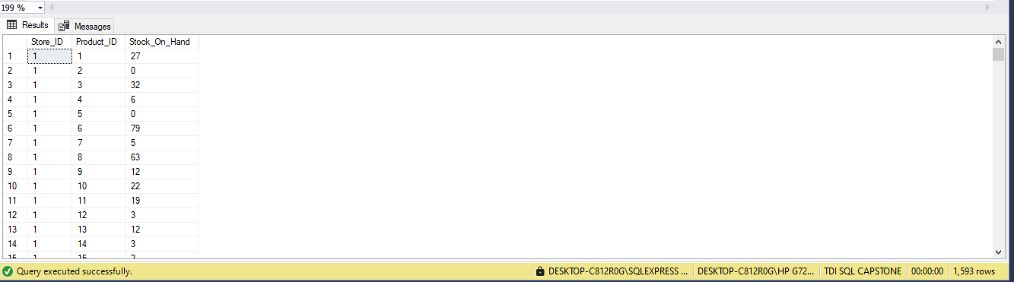

--#Checking for Null values in the Inventory_data
SELECT COUNT(*)
FROM MTD_inventory
WHERE
[Store_ID] IS NULL OR
[Product_ID] IS NULL OR
[Stock_On_Hand] IS NULL
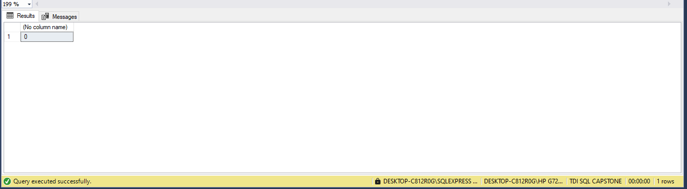
--# Result shows no Null Value

--#Checking for Duplicate values in the Inventory data

--All Records
SELECT *, COUNT(*) AS DuplicateCount
FROM MTD_inventory
GROUP BY[Store_ID],[Product_ID],[Stock_On_Hand] --list of all columns in the table
HAVING COUNT(*) > 1;

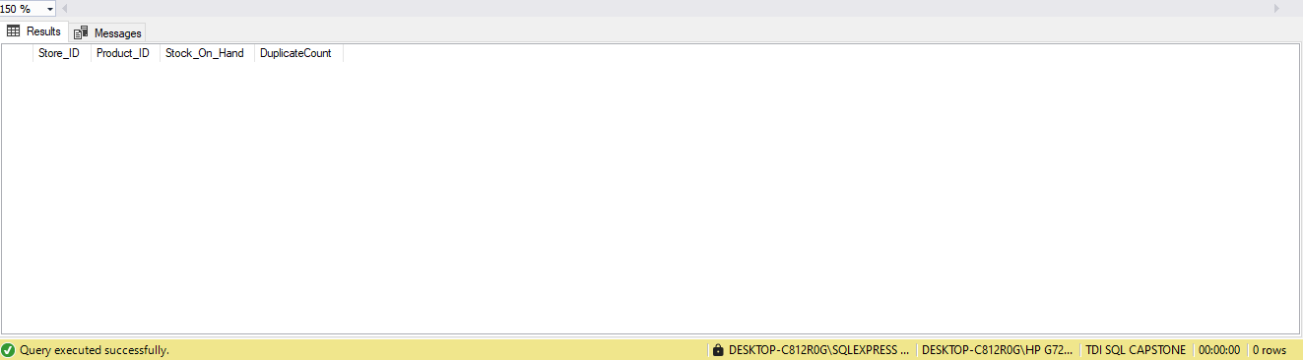

--Given the focus of my analysis on product and sales performance, and the large volume of records in the sales table, I created an index on Product_ID to improve query speed and efficiency.

CREATE INDEX idx_ProductID ON MTD_sales(Product_ID);
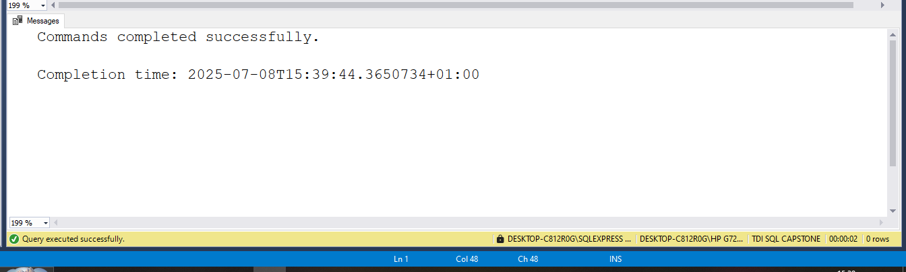

DATA ANALYSIS
--STEP TWO: ANALYSE THE DATA

-- Ques 1. What is the Total Revenue Generated?
(Revenue = Units Sold × Product Price)
SELECT SUM(s.Units * p.Product_Price) AS Total_Revenue
FROM [MTD_sales] s
JOIN [MTD_products] p ON s.Product_ID = p.Product_ID;

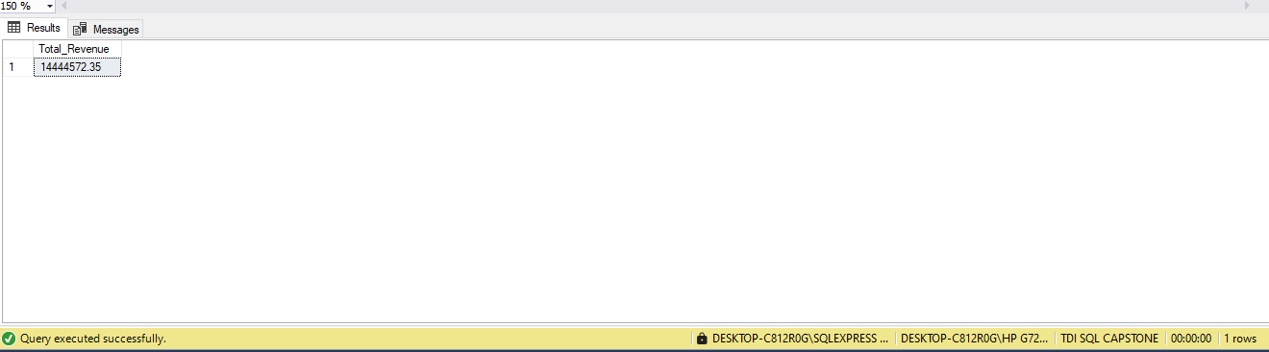

-- Ques 2. Total Profit
(Profit = (Price – Cost) × Units Sold)
SELECT SUM((p.Product_Price - p.Product_Cost) * s.Units) AS Total_Profit
FROM [MTD_sales] s
JOIN [MTD_products] p ON s.Product_ID = p.Product_ID;

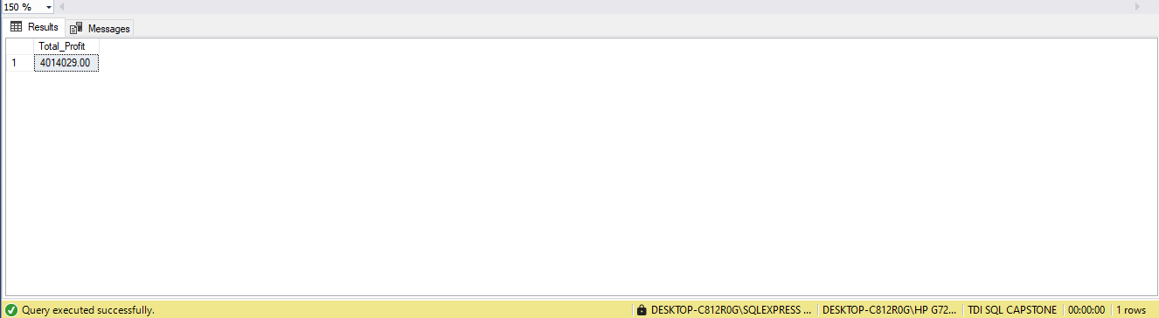

--Ques 3. Average Profit per Unit
SELECT
SUM((p.Product_Price - p.Product_Cost) * s.Units) * 1.0 / SUM(s.Units) AS Avg_Profit_Per_Unit
FROM [MTD_sales] s
JOIN [MTD_products] p ON s.Product_ID = p.Product_ID;

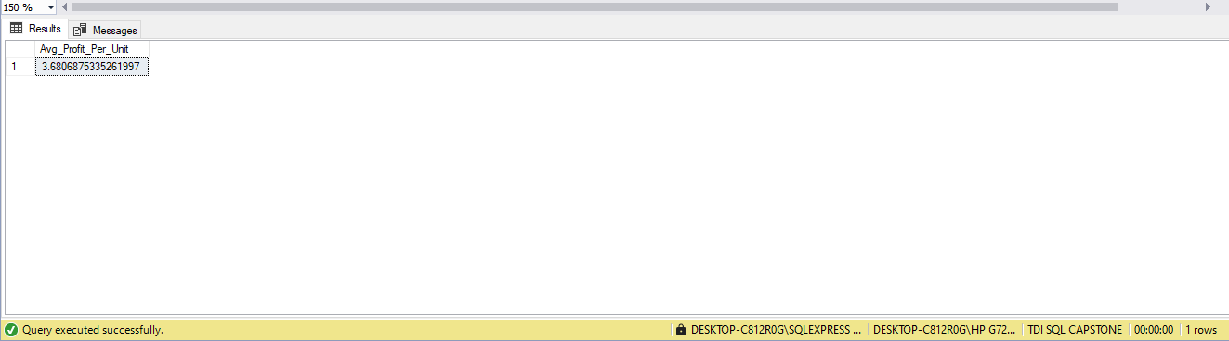

--Ques 4. Total Products Sold
(Total number of units sold)
SELECT SUM(Units) AS Total_Products_Sold
FROM [MTD_sales];
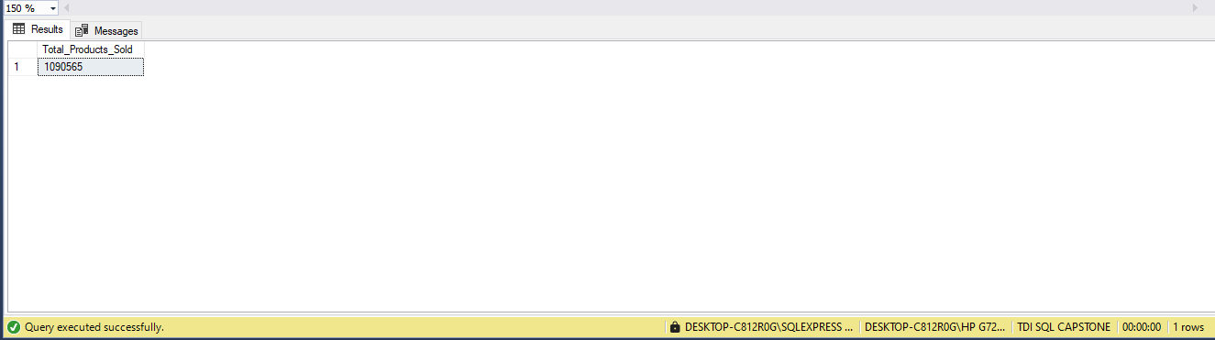

--Ques 5. Total Sales
SELECT COUNT(Sale_ID) AS Total_Sales
FROM [MTD_sales];
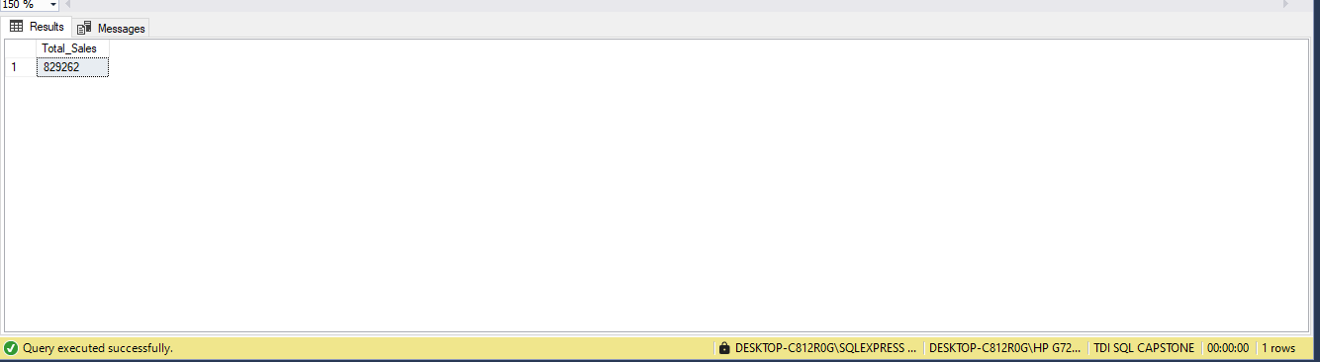

--Ques 6. Average Profit Margin
(Profit margin = (Price – Cost) / Price)
SELECT
AVG(CAST((p.Product_Price - p.Product_Cost) AS FLOAT) / NULLIF(p.Product_Price, 0)) AS Avg_Profit_Margin
FROM [MTD_products] p;

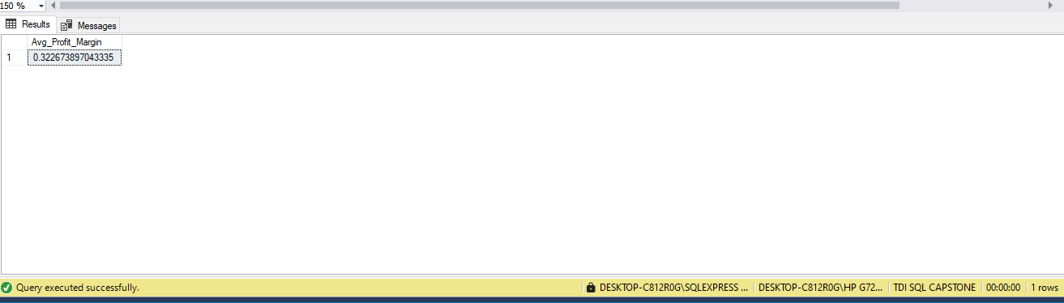

--Ques 7. What is the total count of distinct products being sold?
SELECT COUNT(DISTINCT Product_ID) AS Products_Count
FROM [MTD_sales];
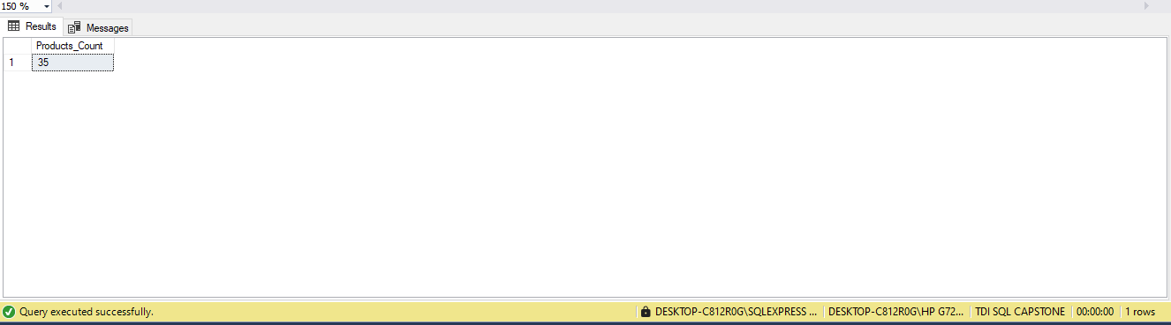

--Ques 8 What is the total count of distinct products Category?

SELECT COUNT(DISTINCT Product_Category) AS Product_Category_Count
FROM [MTD_products];
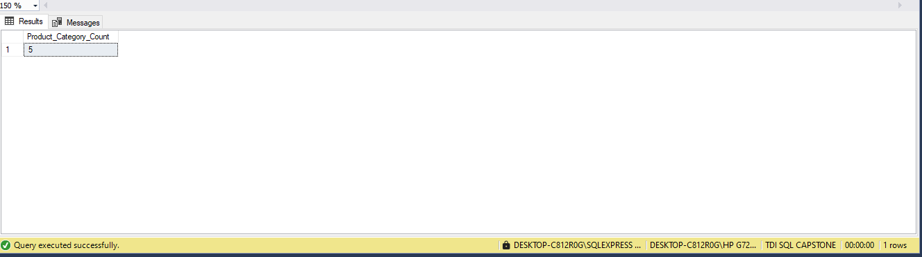

--Ques 9. Which products and categories drive the highest sales?
SELECT TOP 10
p.Product_Name,
p.Product_Category,
SUM(s.Units) AS Total_Units_Sold
FROM [MTD_sales] s
JOIN [MTD_products] p ON s.Product_ID = p.Product_ID
GROUP BY p.Product_Category, p.Product_Name
ORDER BY Total_Units_Sold DESC;
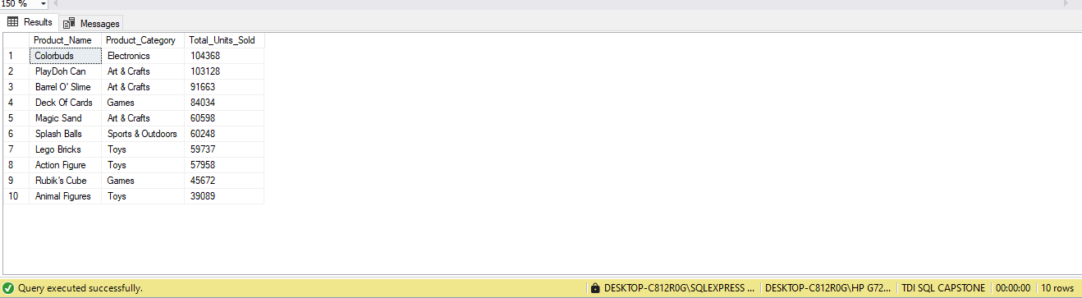

--Ques 10. Which products and categories drive the lowest sales?
SELECT TOP 10
p.Product_Name,
p.Product_Category,
SUM(s.Units) AS Total_Units_Sold
FROM [MTD_sales] s
JOIN [MTD_products] p ON s.Product_ID = p.Product_ID
GROUP BY p.Product_Category, p.Product_Name
ORDER BY Total_Units_Sold ASC;
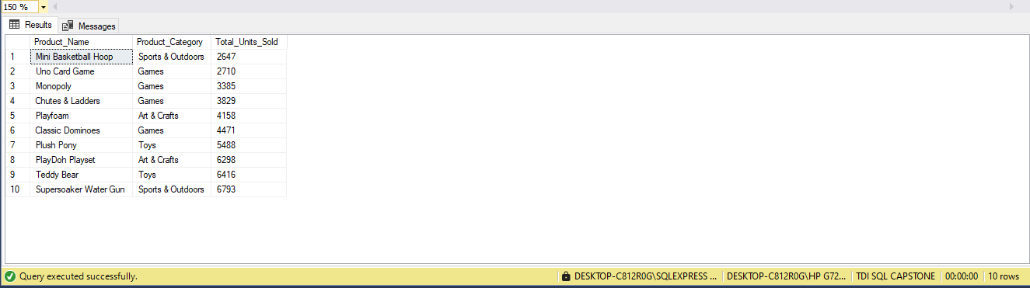

-- Ques 11. Which Product Categories drive the Most and Least sales?

SELECT
p.Product_Category,
SUM(s.Units) AS Total_Products_Sold
FROM
[dbo].[MTD_products] p
JOIN
[dbo].[MTD_sales] s ON p.Product_ID = s.Product_ID
GROUP BY
p.Product_Category
ORDER BY
Total_Products_Sold DESC; -- Change to ASC for Least Sales
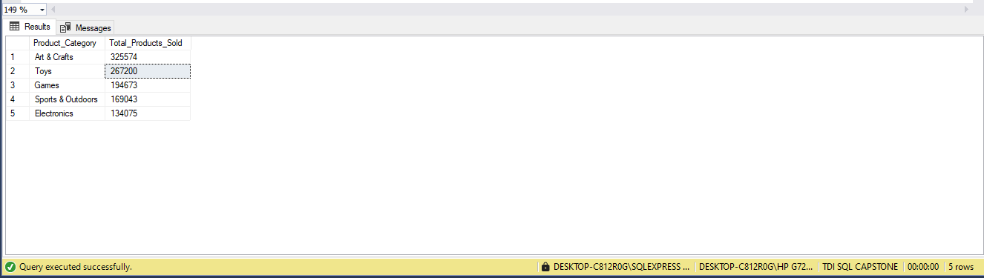

--Ques 12. Which products generate the most profit?
SELECT TOP 10
p.Product_Name,
SUM((p.Product_Price - p.Product_Cost) * s.Units) AS Total_Profit
FROM [MTD_sales] s
JOIN [MTD_products] p ON s.Product_ID = p.Product_ID
GROUP BY p.Product_Name
ORDER BY Total_Profit DESC;
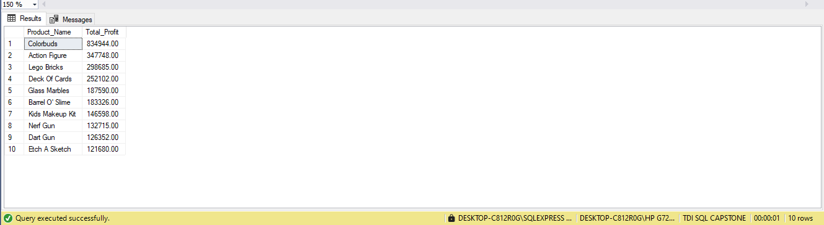

--Ques 13. Which products generate the least profit?
SELECT TOP 5
p.Product_Name,
SUM((p.Product_Price - p.Product_Cost) * s.Units) AS Total_Profit
FROM [MTD_sales] s
JOIN [MTD_products] p ON s.Product_ID = p.Product_ID
GROUP BY p.Product_Name
ORDER BY Total_Profit ASC;
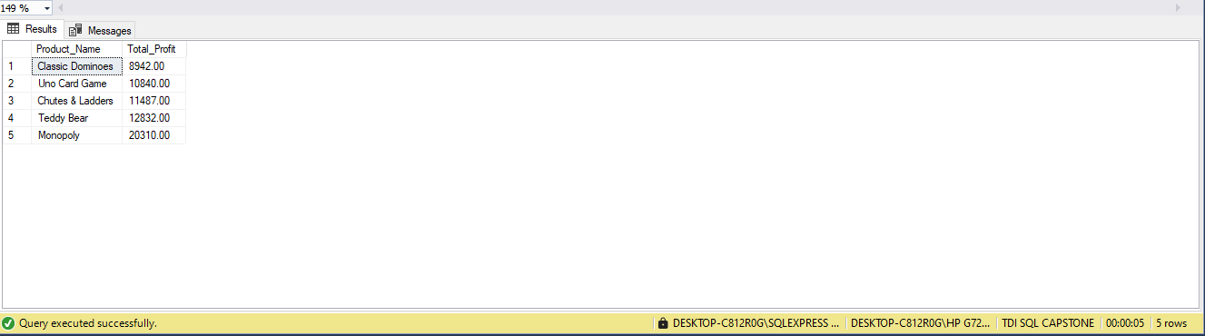

--Ques 14. Which product categories are most and least profitable?
SELECT
p.Product_Category,
SUM((p.Product_Price - p.Product_Cost) * s.Units) AS Category_Profit
FROM [MTD_sales] s
JOIN [MTD_products] p ON s.Product_ID = p.Product_ID
GROUP BY p.Product_Category
ORDER BY Category_Profit DESC;
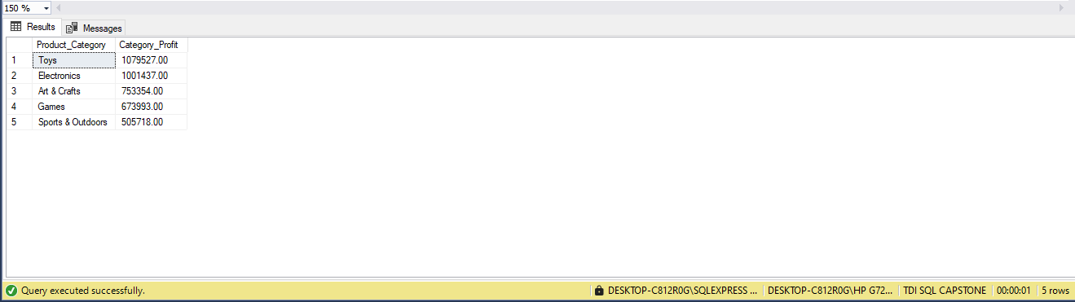

--Quest 15. Which products remain in inventory the longest?
SELECT TOP 10
p.Product_Name,
SUM(i.Stock_On_Hand) AS Total_Stock_On_Hand
FROM [MTD_inventory] i
JOIN [MTD_products] p ON i.Product_ID = p.Product_ID
GROUP BY p.Product_Name
ORDER BY Total_Stock_On_Hand DESC;
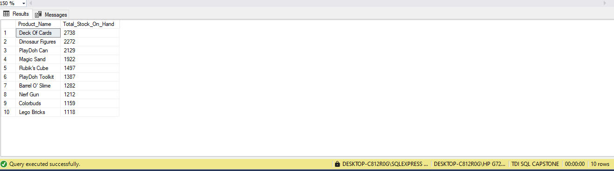

--Ques 16. What are the monthly and seasonal sales trends?
SELECT
YEAR(s.Date) AS Year,
MONTH(s.Date) AS Month,
SUM(s.Units) AS Monthly_Sales
FROM [MTD_sales] s
GROUP BY YEAR(s.Date), MONTH(s.Date)
ORDER BY Year, Month;
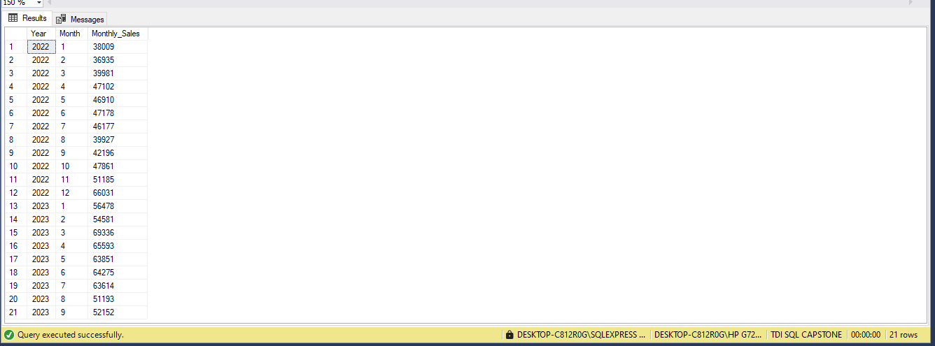

--Ques 17. Which months have the highest and lowest product sales?
SELECT
MONTH(s.Date) AS Month,
SUM(s.Units) AS Total_Sales
FROM [MTD_sales] s
GROUP BY MONTH(s.Date)
ORDER BY Total_Sales DESC;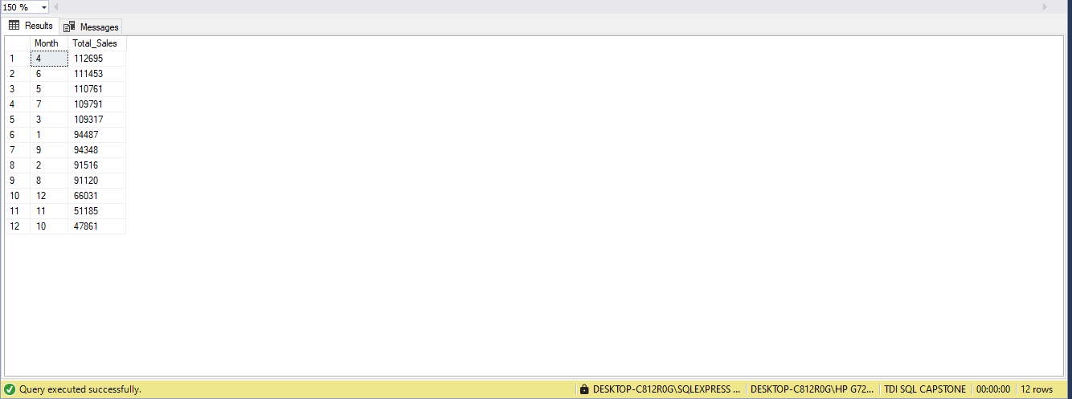
--Ques 18. Which days of the week record the highest number of transactions?
SELECT
DATENAME(WEEKDAY, s.Date) AS DayOfWeek,
COUNT(*) AS Transactions
FROM [MTD_sales] s
GROUP BY DATENAME(WEEKDAY, s.Date)
ORDER BY Transactions DESC;
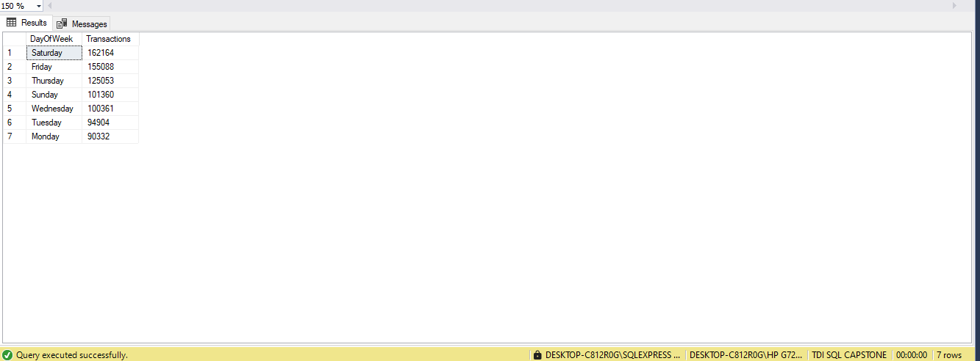

--Ques 19. How many Stores are there?
SELECT COUNT(*) AS Total_Stores
FROM [MTD_stores];
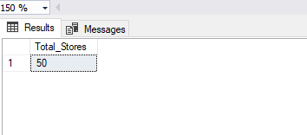

--Ques 20. Which stores sell the most products?
SELECT TOP 10
st.Store_Name,
SUM(s.Units) AS Total_Units_Sold
FROM [MTD_sales] s
JOIN [MTD_stores] st ON s.Store_ID = st.Store_ID
GROUP BY st.Store_Name
ORDER BY Total_Units_Sold DESC;
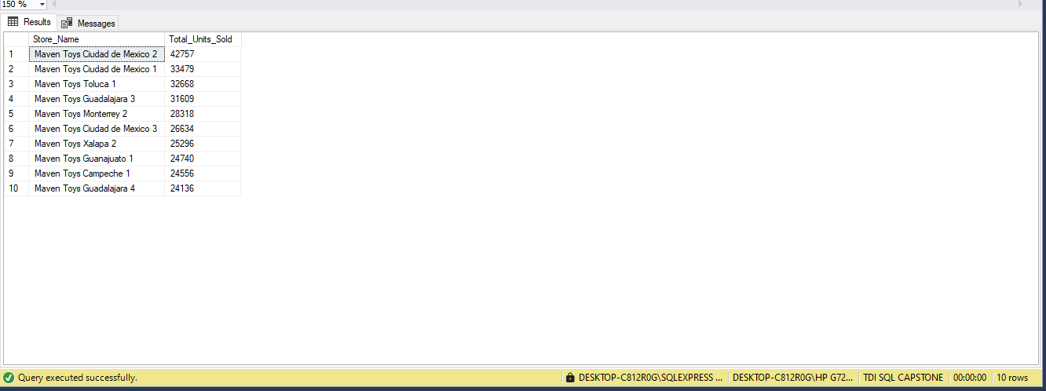

--Ques 21. How many cities are there?
SELECT COUNT(DISTINCT Store_City) AS Total_Cities
FROM [MTD_stores];
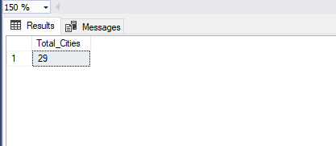

--Ques 22. Which store locations perform best in terms of product sales?
SELECT
st.Store_Location,
SUM(s.Units) AS Total_Units_Sold
FROM [MTD_sales] s
JOIN [MTD_stores] st ON s.Store_ID = st.Store_ID
GROUP BY st.Store_Location
ORDER BY Total_Units_Sold DESC;
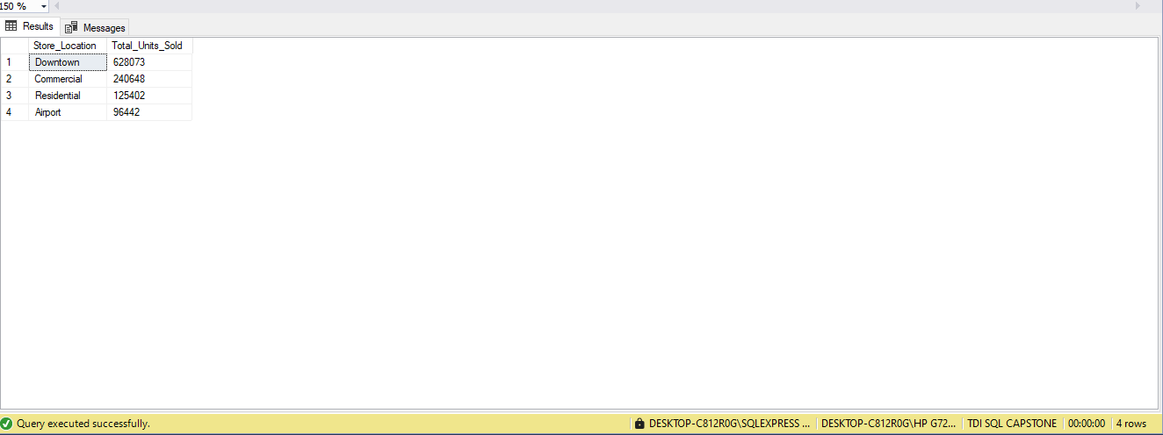

--Ques 23. Are certain stores more profitable based on how long they've been open?
-- Step 1: Calculate Years_Operating per store using MAX sale date
WITH Store_Age AS (
SELECT
st.Store_ID,
st.Store_Name,
DATEDIFF(YEAR, st.Store_Open_Date, MAX(s.Date)) AS Years_Operating
FROM MTD_sales s
JOIN MTD_stores st ON s.Store_ID = st.Store_ID
GROUP BY st.Store_ID, st.Store_Name, st.Store_Open_Date
)

-- Step 2: Join with product and sales data to calculate total profit
SELECT
sa.Store_Name,
sa.Years_Operating,
SUM((p.Product_Price - p.Product_Cost) * s.Units) AS Total_Profit
FROM MTD_sales s
JOIN MTD_products p ON s.Product_ID = p.Product_ID
JOIN Store_Age sa ON s.Store_ID = sa.Store_ID
GROUP BY sa.Store_Name, sa.Years_Operating;
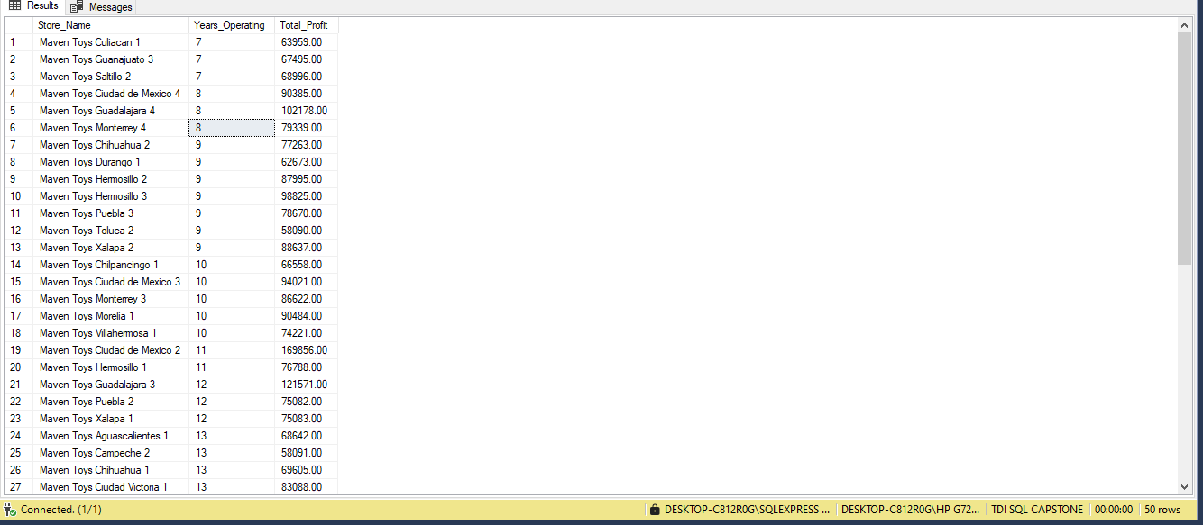

--Ques 24. Which stores hold the highest stock levels, and are those products selling?
SELECT
st.Store_Name,
st. Store_Id,
SUM(i.Stock_On_Hand) AS Stock_Level,
SUM(s.Units) AS Units_Sold
FROM [MTD_inventory] i
JOIN [MTD_stores] st ON i.Store_ID = st.Store_ID
JOIN [MTD_sales] s ON s.Store_ID = i.Store_ID AND s.Product_ID = i.Product_ID
GROUP BY st.Store_Name, st. Store_Id
ORDER BY Stock_Level DESC;
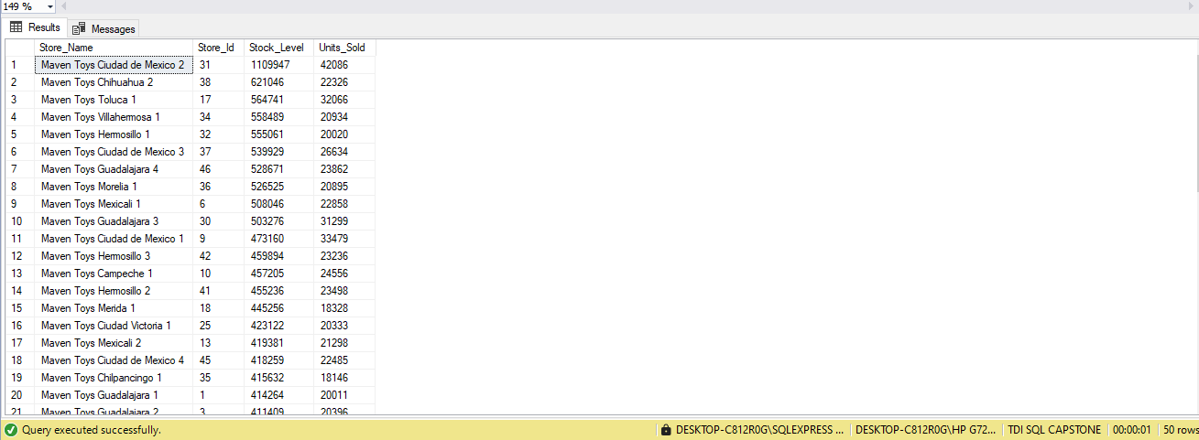

--Ques 25. Which stores generate the highest revenue and profit?
SELECT
st.Store_Name,
SUM(s.Units * p.Product_Price) AS Total_Revenue,
SUM((p.Product_Price - p.Product_Cost) * s.Units) AS Total_Profit
FROM [MTD_sales] s
JOIN [MTD_products] p ON s.Product_ID = p.Product_ID
JOIN [MTD_stores] st ON s.Store_ID = st.Store_ID
GROUP BY st.Store_Name
ORDER BY Total_Revenue DESC;
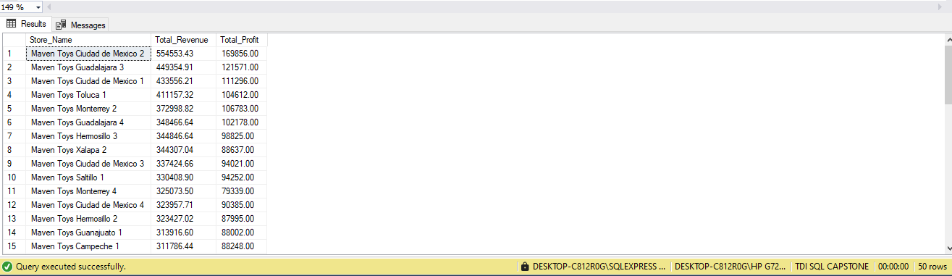

--Ques 27. Which cities record the highest sales volumes by product?
SELECT
st.Store_City,
SUM(s.Units) AS Total_Units_Sold
FROM [MTD_sales] s
JOIN [MTD_stores] st ON s.Store_ID = st.Store_ID
GROUP BY st.Store_City
ORDER BY Total_Units_Sold DESC;
